GUJARAT, PIN – 389260
Off. Ph. No:02675220007College E-mail ID:aaccsantrampur@gmail.com;Website: www.accsantrampur.in

Full Name  Title/First name/ Second name/ Surname |  |  |  | Dr. Bhartiben Dhuljibhai Dhanula |  |  |  |  |  |  |  | Photograph
Designation  (Department) |  |  |  | Assistant Professor  (Dept.of History ) |  |  |  |  |  |  |  | 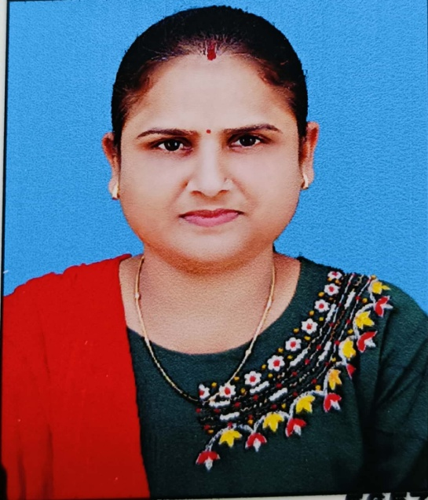
Address | Current |  |  | Adiwasi Arts & Commerce College,  Santrampur : 389260
Address | Permanent
Contact No. |  |  |  | 9909755582
Email- |  |  |  | Bhartidhanula111@gmail.com
Date of joining |  |  |  | 07/12/2015
Date of birth |  |  |  | 06/01/1982 |  |  |  | Employment No. |  |  | 4459
 |  |  | Educational Qualifications
Degree |  |  |  |  | Institution |  |  |  | Year |  |  |  | Remarks
B.A |  |  |  |  | S.S Maheta Arts & M.M Patel Comm.College, Himmatnagar |  |  |  | 2007
M.A  (Specialization) |  | History |  |  | Shree Kaljibhai R Katara Arts College, Shamlaji |  |  |  | 2010
M. Phil. |  |  |  |  | H.N.G.U, Patan |  |  |  | 2014
Ph. D. |  |  |  |  | H.N.G.U, Patan |  |  |  | 2023
NET/SLET |  |  |  |  | M.S.Uni.Vadodara |  |  |  | 2011
Bed
 |  |  | Career Profile ( Research & Teaching Experience)
Organization/ Institution |  |  |  |  |  |  | Designation |  |  | Duration |  |  |  | Role
Adiwasi Arts and Commerce College,Santrampur |  |  |  |  |  |  | Assistant Professor |  |  | Since 07/12/2015 |  |  |  | Teaching
Research Areas of Interest :-
Teaching areas of Interest :-
Publications Profile :-
Conference Organization / Presentations:- National and International Seminar
2020 National Seminar – Paper:- Gandhi Philosophy
2021 International Seminar- Paper- Svatantra Sangram ane Mahesana Jillo
Research Projects ( Minor – Major Grants/Research Collaboration :-
Awards and Distinctions :-
Administrative Assignments:-
Association With Professional Bodies:-
Other Activities
1. University Paper Setter &Examiner

